St Margaret Clitherow Catholic Primary School – Sports Premium Funding 2021-2022
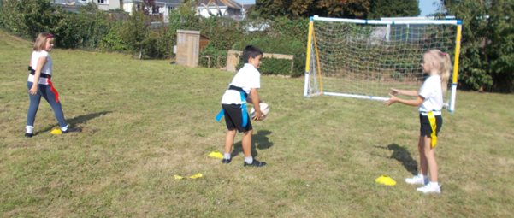
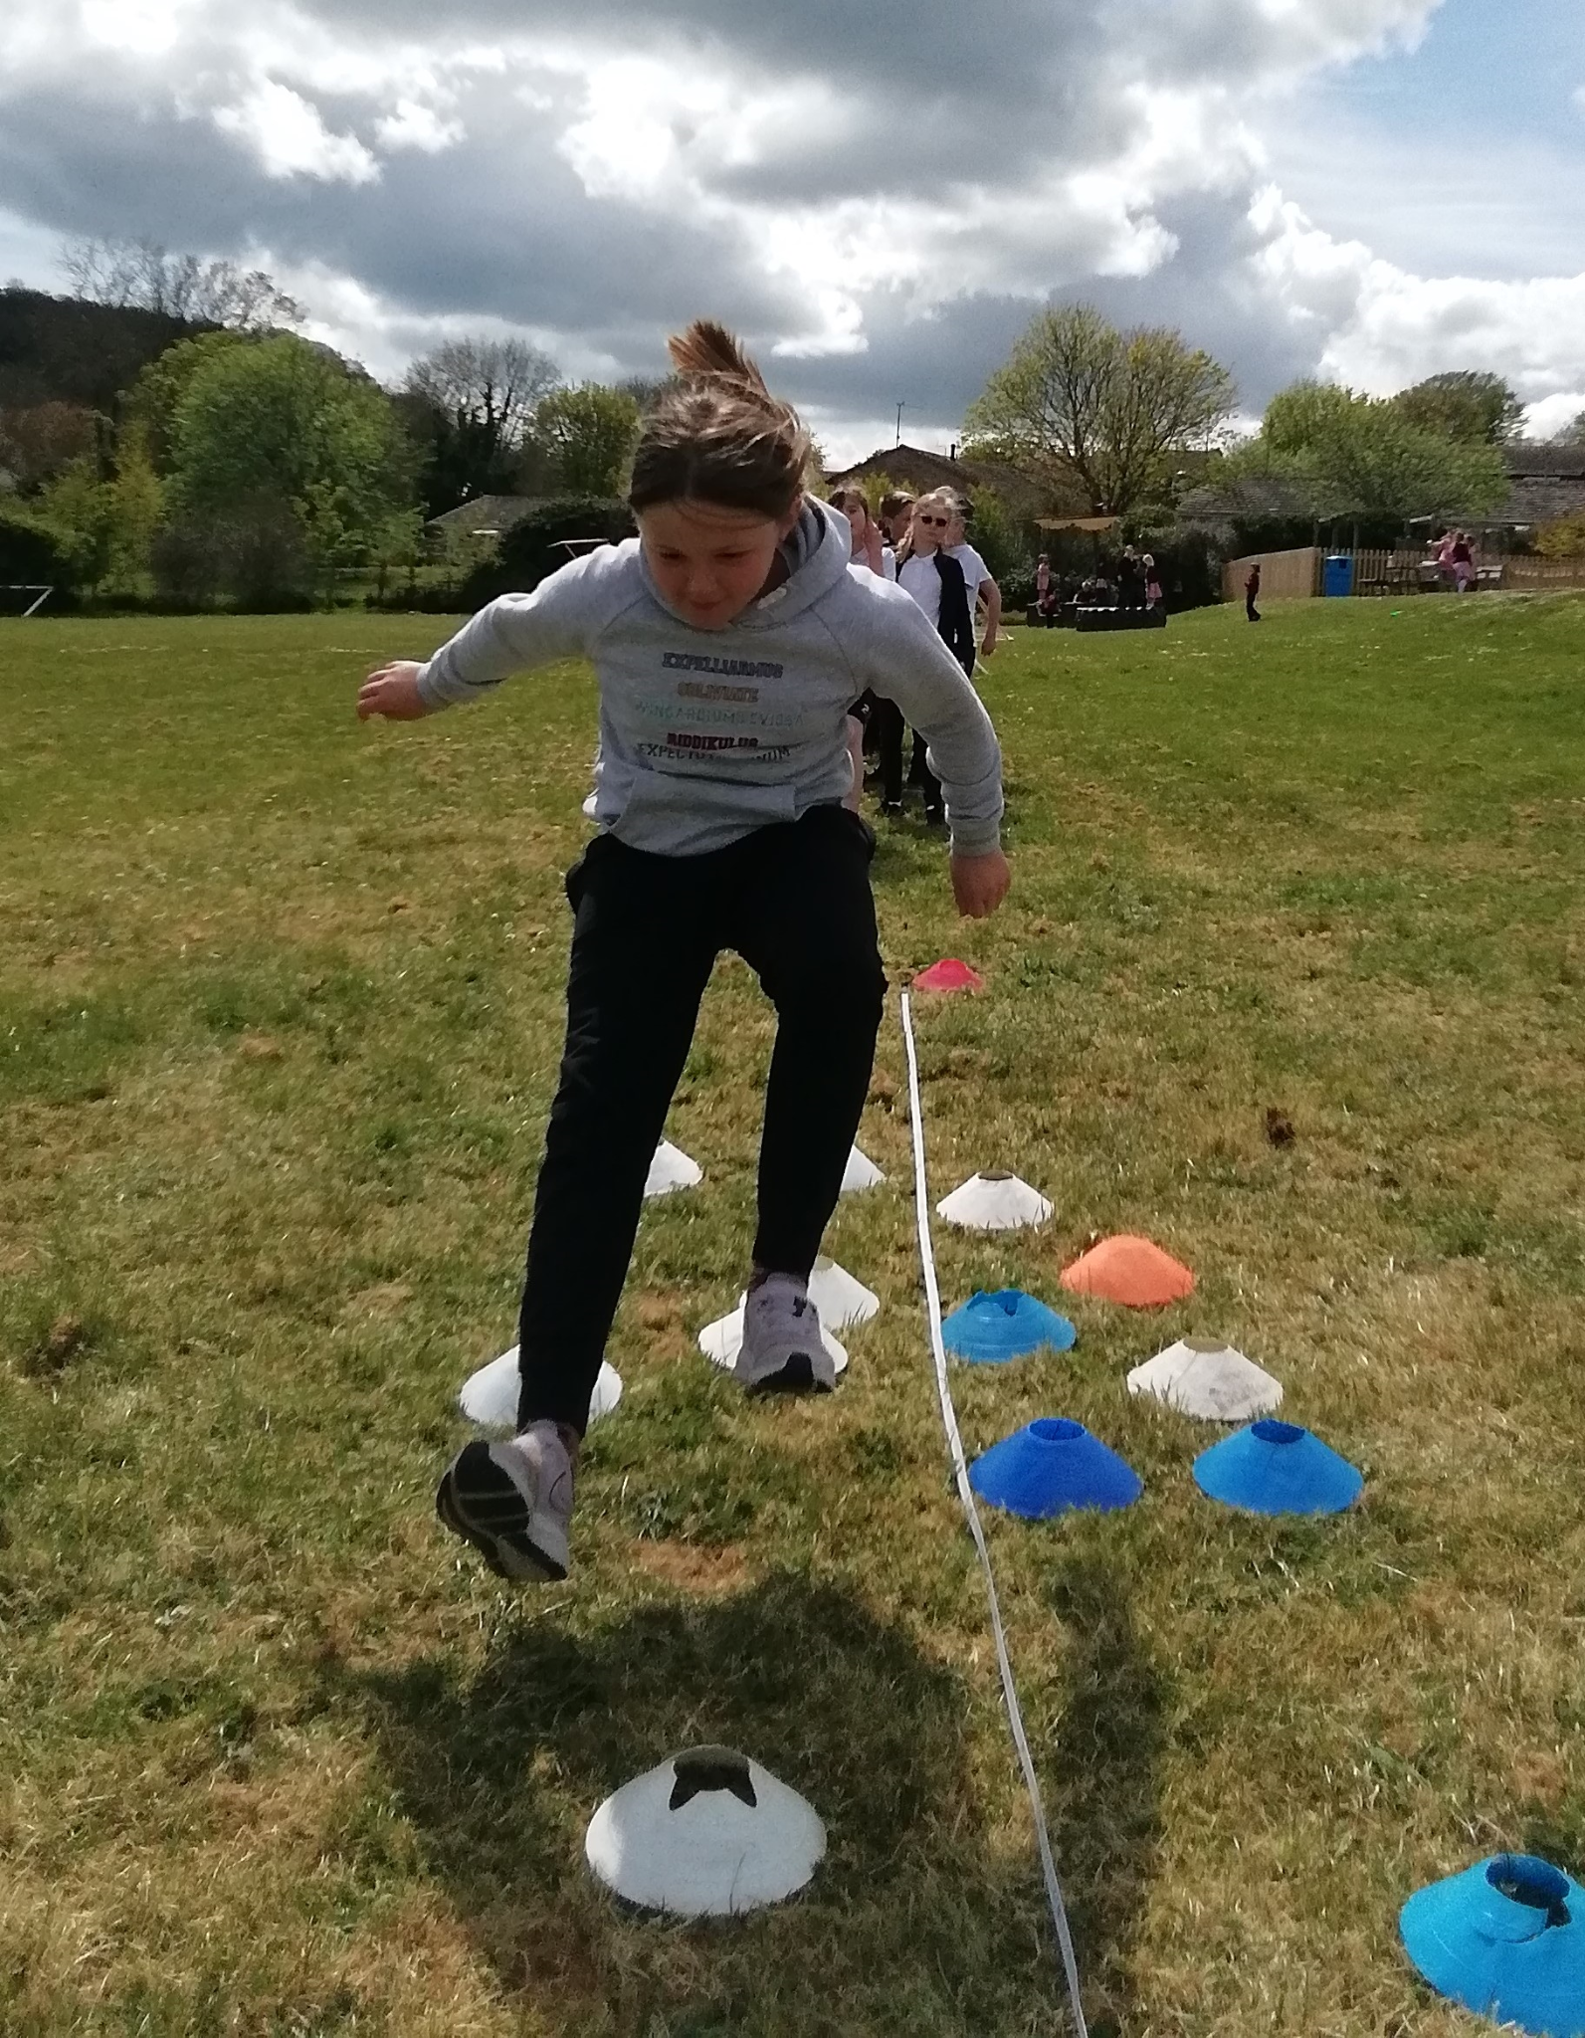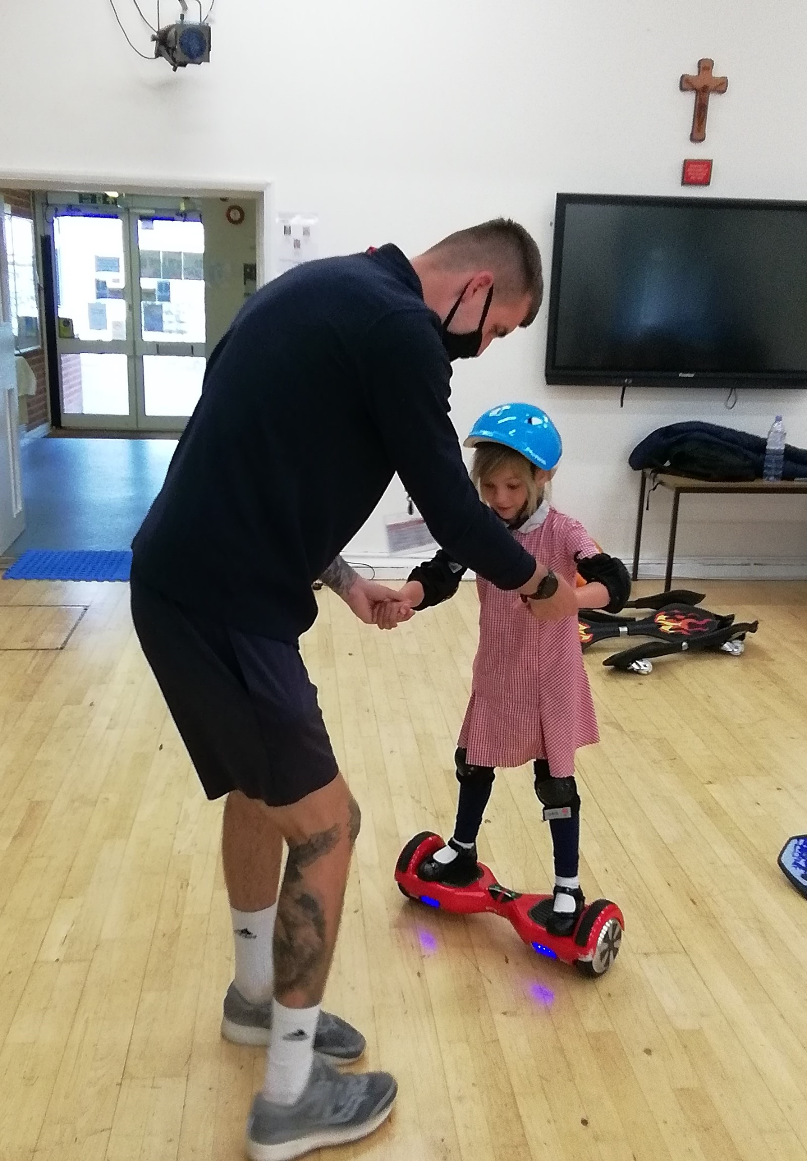

Key achievements to date: | Areas for further improvement and baseline evidence of need:
Throughout the year, all children have made good progress within different disciplines of sport. Every child at the school has participated in a wide variety of sporting activities, within timetabled school lessons and within extra-curricular clubs. The school has invested in numerous pieces of equipment and facilities which has allowed all children to work within a safe and stimulating environment. The school has invested in different schemes to ensure that all children participate daily in exercise and the results have been noticeable.  - High quality PE lessons have been taught, increasing staff knowledge and confidence in specific areas of PE.  - Children have been assessed as physically fit and active.  - Assessments have been conducted at the start and end of the year and these show improvement in the children to achieve key tasks, leading to greater skill and control in all sports.  - KS1 children’s fine motor skills have improved, leading to better concentration in lessons and improved handwriting.  - Pupils are more active in PE lessons - take part without stopping to rest.  - Standards have been achieved in PE NC.  - Attitudes to learning improved in KS2 classes - better concentration in lessons (particularly after the Golden Mile or other schemes we run).  - Use of all equipment within the school has ensured that playtimes have been enriching and enjoyable – leading to better behaviour across the school.  - After school Clubs led to increased participation in sport across the school.  - A greater number of children are engaged in different sports clubs and activities both in and outside school. Less active pupils are involved in a sport/club they enjoy. Noncompetitive sports are being enjoyed by a range of pupils in school.  - Children have the opportunity to be active outside teaching hours. A large number of children attend these clubs and this number has been increasing over the year. | - An increase in CPD opportunities for the whole school.  - Improve participation in extracurricular sporting clubs, across all years.  - Ensure that all children travel to school in a healthy/ environmentally friendly manner – thus increasing physical activity and helping towards building a green school.  - Further develop positive playtimes and the range of activities the children participate in, giving them opportunities to organize and lead.  - Develop the knowledge and skills of support staff regarding progression in physical development and how to improve children’s attainment in PE.  - Use specialist teaching to ensure high quality learning.  - PE specialists provide a wide range of equipment to excite and enthuse children.  - Improve the access to large apparatus in unstructured time for Early Years and KS1 to improve their physical skills.  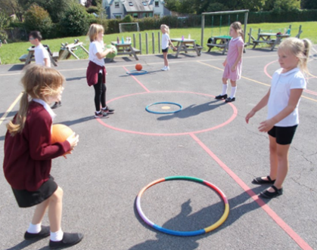

Meeting national curriculum requirements for swimming and water safety | Please complete all of the below:
What percentage of your Year 6 pupils could swim competently, confidently and proficiently over a distance of at least 25 metres when they left your primary school at the end of last academic year? | 90%
What percentage of your Year 6 pupils could use a range of strokes effectively [for example, front crawl, backstroke and breaststroke] when they left your primary school at the end of last academic year? | 60%
What percentage of your Year 6 pupils could perform safe self-rescue in different water-based situations when they left your primary school at the end of last academic year? | 60%
Schools can choose to use the Primary PE and Sport Premium to provide additional provision for swimming but this must be for activity over and above the national curriculum requirements. Have you used it in this way? | Yes

Academic Year: 2021/22 | Total fund allocated: £16640  + £8795 carry forward from £20/21  Total £25,435 |  | Date: September 2021
Key indicator 1: The engagement of all pupils in regular physical activity – Chief Medical Officer guidelines recommend that primary school children undertake at least 30 minutes of physical activity a day in school |  |  |  |  | Percentage of total allocation:
 |  |  |  |  | 100%
School focus with clarity on intended impact on pupils: | Actions to achieve: | Funding allocated: |  | Evidence and impact: | Sustainability and suggested next steps:

Support and training for teachers and TA’s in PE delivery by using Kinetic Sports (3 days per week).  Developing and increasing physical activity for KS1 children using the large equipment.  PE lead to develop outdoor learning opportunities for all children-  Continue to use Golden Mile and GoNoodle schemes to ensure that all children receive daily (short burst) exercise.  Continue to use GetSet4PE scheme - Investment package.  Continue PE sessions 2x 1hour sessions per week. | Organised sports activities for children at lunchtimes building on the learning going on in lessons, consolidating and practicing skills.  Create a variety of outdoor activities for children to participate in during lunchtimes.  Support and CPD for teachers and TA’s.  After school clubs 3 times per week, using resources that school doesn’t have e.g. Zorbs and street skates.  Improved participation in after school clubs for all year groups.  Get quotes to restore safety flooring  Action company to start work.  Playtime leaders undergo specific training delivered by Mrs Cartledge to ensure that they can help MTA’s deliver enjoyable lunchtime games.  Children will have to apply for a play leader role.  This will be sustainable through the constant training of Y5 pupil’s year-on-year.  Ensure that all year groups engage with the scheme and are actively participating in the schemes  Structured scheme to support staff with the delivery, assessment and reporting of PE. Use wellbeing element.  All classes deliver increased timings.  Mindfulness activities introduced on a daily basis. | £13,000 | Start of year:  - Use an emotional intelligence questionnaire from year to year to measure the impact PE has on mental health.  - Is there a noticeable improvement in the children’s mental wellbeing?  - Book Kinetic Sports.  - Good attendance for all groups in after school clubs.  - More physically able children.  - Data to be compared to last year, good development of skills.  - Gross motor skills are improved for KS1 children.  - Balance, agility and coordination improved.  - Risk taking for younger children is facilitated within a safe environment.  - Children’s stamina for physical movement increased, children active for a sustained period of time.  - Train Year 5 children to lead sessions during lunchtimes.  These children can then train and upskill the following years cohort – this will then ensure that many children will become play leaders when in Years 3, 4 or 5, thus providing sustained progress.  - Continue to engage children in physical activity outside of organised PE lessons, after school clubs and organised sports.  - Staff and child questionnaire.  - Impact on mental wellbeing and attainment? | Mid-Term Review:  - Kinetic sports delivering 2x 2 hour PE lessons for every class each week..  - Kinetic sports supporting sports activities during 3x lunchtimes, building on prior learning and practicing skills. A variety of activities are provided.  - A variety of after school clubs are being provided for the children, most clubs have at least half of the class attending, including children with SEND and who are PP.  - Children showing an enjoyment for sport and skill development has improved.  - In the process of applying for a National Lottery Grant to fund the works needed and purchase the equipment.  - Play leaders have been interviewed and have undergone training and have been supporting children on the KS1 playground.  - KS1 children showing a real engagement with games and play leaders modeling and enforcing positive behavior.  - Kinetic sports are now delivering using the structure of GetSet4PE scheme (Spring term).  - GetSet4PE assessment used to record swimming data from Dolphins class.  - All classes continue to have 2 hours of PE per week.  - Mindfulness and meditation activities done in every class on a daily basis. | End of year review:  - Kinetics sports have continued throughout the year. RW has built good relationships with the children and they have made good progress. A high percentage of children really enjoy PE.  - Kinetic sports to continue next year using the same format.  - National Lottery Grant not applied for.  - £7,000 of funding used to upgrade the existing wet pour flooring.  - Target date for flooring installation 01.08.22.  - Play Leaders have successfully been involved in supporting KS1 children during lunchtime playtimes.  - Children having active lunchtimes. Timetabling constraints have made it tricky to do daily short burst exercise. Two hours of PE per week continuing.  - As per mid-term review.  - All classes continue to have 2 hours of PE per week.  - Mindfulness and meditation activities done in every class on a daily basis.  - The above will continue next year.

Key indicator 2: The profile of PE and sport being raised across the school as a tool for whole school improvement |  |  |  | Percentage of total allocation:
 |  |  |  | 0.5%
School focus with clarity on intended impact on pupils: | Actions to achieve: | Funding allocated: | Evidence and impact: | Sustainability and suggested next steps:
Introduce certificates for weekly Celebration assemblies continue to recognise and celebrate achievement and effort in sports/PE both in-school and outside of school.  Sports day 2022.  Develop lunchtime play leaders.  Offer after school clubs | Achievements celebrated in assembly (match results + notable achievements in lessons etc.).  Different classes to do dance/gymnastics displays as part of celebration of learning events  Certificates, trophies and medals to recognise achievement.  Track lines for sports day.  Y5 pupils to be trained as play leaders for 21-22.  Increase diversity of sporting clubs offered to increase student participation and development of skills across the curriculum. | £145 | - Emotional intelligence tests to be conducted to measure children’s enjoyment of sporting activities.  - Achievements celebrated and the profile of physical activity improved.  - Children using track during sports day.  - Children working with other classes to support and encourage physical activity.  - Increased confidence in children who are play leaders.  - What has been the impact on learning following extra provision at lunchtime?  - Continue offering a variety of after school clubs with Kinetic Sports.  Improve participation numbers going forward. | - Weekly PE certificates introduced. Given out during achievers assembly on a Friday pm.  - Now that covid restrictions have been lifted, PE displays can now become a part of achievers assemblies where suitable.  - Sports Day scheduled for 29th June 2022.  - Play Leaders have been supporting children on the KS1 playground at lunchtimes.  - Play leaders rising to the challenge of their role and taking it seriously. Confidence increased.  - KS1 children showing a real engagement with games and play leaders modeling and enforcing positive behavior.  - A good variety of after school clubs have been offered: Zorbing, Street Skate, Dodgeball, Tag Rugby, Basketball, Cricket, Golf and Multi-sports.  - Participation is good for all children including SEND and PP. | - Weekly certificates have continued and end of year certificates will be given.  - A very successful sports day was held with all children competing throughout the school.  - JH painted the track lines. Paint had to be bought at a cost of £40.  - As per mid-term review.  - More personalised clubs have been offered during the summer term based on children's interests, for example tennis.  - After school clubs to continue next academic year.

Key indicator 3: Increased confidence, knowledge and skills of all staff in teaching PE and sport |  |  |  | Percentage of total allocation:
 |  |  |  | 1.5%
School focus with clarity on intended  impact on pupils: | Actions to achieve: | Funding  allocated: | Evidence and impact: | Sustainability and suggested next steps:
PE lead will monitor the delivery of PE working closely with Kinetic Sports.  Active lunches to be further embedded and enhanced by MTA lead through ongoing  support, training and guidance for MTAs and Play leaders.  PE lead to provide support and CPD to staff including. | Release time for PE lead  Continue to develop Active lunches maintaining its new high profile through display in the hall.  Advertise, interview and appoint play leaders for 2021-2022.  Develop staff expertise in delivering quality PE. | 3 x 0.5 days for termly monitoring and working alongside teachers. £300  EC covered PE lead. | - PE lead to monitor the impact of Kinetic Sports.  - PE lead to observe sessions being taught.  - Further displays in KS1 and KS2 areas, to show play leaders and planning.  - LC and EOS to appoint new play leaders within the first six weeks of the Autumn Term.  - Further training for MTAs.  - MTA packs to be produced.  - Pupil conferencing.  - Tracking of assessment data across all groups.  - Monitor clubs attended outside of school.  - Make sure clubs are accessible to all children.  - PE lead to identify any further support needed by staff. | - Monitoring completed with LD and GA: 17.02.22, 01.03.22 and 05.04.22.  - Next moderation is scheduled for 03.05.22.  - Kinetic sports supporting sports activities during 3x lunchtimes, building on prior learning and practicing skills. A variety of activities are provided.  - Play leaders appointed and supporting in KS1 playground. | - Moderation to continue next academic year.  - RW doing a Level 4 apprenticeship with South Devon College.  - RW tutor observation 08.07.22.  - MTA training is challenging due to staff numbers.  - Staff observing RW during PE sessions to develop practice.  - Continue this into the next academic year.
Key indicator 4: Broader experience of a range of sports and activities offered to all pupils |  |  |  | Percentage of total allocation:
 |  |  |  | 0%
School focus with clarity on intended  impact on pupils: | Actions to achieve: | Funding  allocated: | Evidence and impact: | Sustainability and suggested  next steps:
Continue to offer a wider range of activities both within and outside the curriculum in order to get more pupils involved. Focus particularly on those pupils who do not take up additional PE and Sport opportunities.  Organise use of outdoor Table Tennis tables so that all KS2 children have the opportunity to develop their skills. | Kinetic Sport to offer lunchtime and after school activities.  Ongoing update of resources/kit.  RW from Kinetic sport to do table tennis during one lunchtime. |  | - Kinetic Sport to run a range of after school clubs.  - Review resources and order any that need replacing or updating.  - Children using table tennis resources and developing coordination. | - Kinetic sports offering lunchtime activities x3 per week.  - A range of after school clubs running.  - Review resources in the summer term.  - Table tennis summer term. | - Resources ordered for KS2 playground to further encourage active lunchtimes £702.  - Resources ordered for the KS1 playground to further encourage active lunchtimes £300.  - Gymnastics benches ordered X4 £600  - Further PE equipment ordered to enhance provision £100.  - KS1 shed ordered to store bikes £400.  - Playground markings ordered for KS2 and KS1 playgrounds £2,000.  - Children have been playing table tennis during the summer term.
Key indicator 5: Increased participation in competitive sport |  |  |  | Percentage of total allocation:
 |  |  |  | 1%
School focus with clarity on intended  impact on pupils: | Actions to achieve: | Funding  allocated: | Evidence and impact: | Sustainability and suggested  next steps:
Engage more children in after school and lunchtime sport activities  Sports Day awards | PE lead to work with Kinetic Sports to devise a schedule of activities.  Brixham Development Academy to deliver an after school football club.  To recognise children’s achievements in sporting events | £200 | - Increased number of children participating in AS clubs.  - Children across school participating in football club.  - Create a schedule for clubs.  - Variety of after school clubs on offer. | - Good uptake for AS clubs.  - Children participate well in the BDA football club after school.  - Sports day awards to be ordered for 29th June 2022. | - After school clubs continue to be positive.  - Stickers given out on sports day and water bottles donated by a parent.
Key indicator 6: Additional Swimming
 |  |  |  | Percentage of total allocation:
 |  |  |  | 5%
School focus with clarity on intended  impact on pupils: | Actions to achieve: | Funding  allocated: | Evidence and impact: | Sustainability and suggested  next steps:
Additional coach for years 5 and 6.  All remaining non-swimmers achieve 25 metres thus meeting the statutory requirements of the national curriculum for PE.  Extra swimming tuition for those in Year 4/5 who are non swimmers. To ensure all existing swimmers increase their attainment by 10 metres thus increasing their confidence in water.  In addition, Y2 to have 6 sessions of swimming | Year 5/6 children to swim in the Autumn 2 Term.  Years 2/3/4 to swim in Spring 2.  To increase students swimming skills and confidence due to lockdown.  To utilise the coach based at the swimming pool to work alongside teachers.  Engage coaches at the pool for KS1 children.  School to participate in the local swimming gala - KS1 and 2 children to take part. | £73 for coach for 6 lessons  £315 pool hire  £350 for KS1 swimming | - All children from Y2 to Y6 have swimming lessons for one term each year. This ensures that they can build on their skills and on their confidence in water from year to year so that by Year 6 the vast majority reach the expected threshold.  - Participate in the local swimming gala. | - Year 5 and 6 children swam in the Autumn term.  - Years 2/3/4 swam in the Spring term .  - An additional coach was put in place for swimming sessions.  - Due to lockdown there was a higher amount of children lacking in water confidence, with some not participating due to medical conditions.  - High percentage unable to swim at all.  - KS1 - Year 2 children participated in swimming sessions. | - Swimming booked for the next academic year.  - No local school gala was organised this year.

