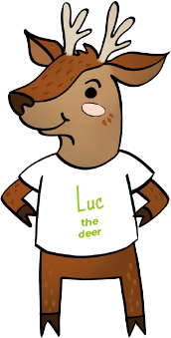
Everyone is special
Human dignity
Luc the deer’s story

Luc has many brothers and sisters. He is the oldest brother, but he reminds his siblings how important they are.

Some of his younger siblings have been upset as they are a bit different. Some have different coloured skin, some are a bit shorter, some a bit slower, one has only three legs.

Luc has a gentle way of reminding them that they are all beautiful and important, just as they are. They are all made by God and have great value.

Luc’s story reminds us that each of us is made in God’s image. This means that everyone is special. We should treat every person the same way we want to be treated.


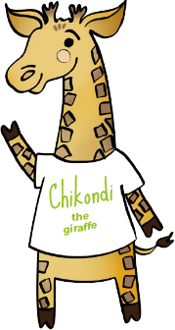
Thinking of everyone
The Common Good
Chikondi the giraffe’s story
Chikondi loves to play hide and seek with her friends. Some of her friends are really good (like spider and mouse). Chikondi is often found first in this game as she struggles to find a way to hide herself because of her really long legs and neck.

One day she thought about not including some of the smaller animals so that she would not be the first picked. But then she realised that it was important for everyone to be included and for everyone to be treated equally.

So now she just giggles to herself whenever she is found! She is happy that everyone is having fun, and everyone has a chance to play together without being left out.

Chikondi’s story tells us that what we do affects everyone. When we make decisions, we should think about the good of everyone.

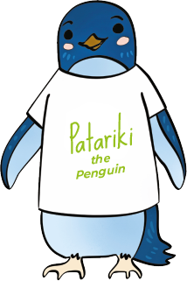
Taking part
Participation
Patariki the penguin’s story
Once every year the penguins come together to a sports festival. Patariki is in charge of making sure that everyone takes part.

Different breeds of penguin join in, Little Blues, Fjorordland crested and Yellow eyed. The events include sprint races, diving, synchronised swimming, shark racing, sand digging and fish eating!

Patariki loves it when everyone takes part. There is nothing better than watching a crowd of penguins cheer for everyone and having fun all together. Those who feel they need support are always given the help they need to participate and enjoy themselves.

When we listen to Patariki’s story we are reminded that we live in community with others, growing together. It is important that we join in.

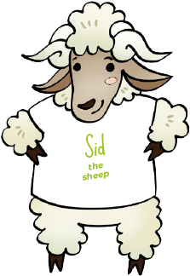
Everyone should
have a say
Subsidiarity
Sid the sheep’s story

Sid enjoys hanging out with his flock in his favourite field. Sometimes their owner, Farmer Dale asks them to move to a new field where the grass is a bit greener but they have come to realise that one field has nicer tasting grass.

One day Farmer Dale tells them they’d be moving fields again, but Sid and his cousins explained that they’d prefer to stay for a few more days until the grass had been eaten. At first Farmer Dale wasn’t happy, but then he realised that the sheep were in a better position to make the decision and it actually affected them most. Now Farmer Dale spends more time listening to the sheep.

Sid’s story helps us to remember that everyone has important ideas and knows what is best for their families and communities. They need to have a say in decisions which affect them.
.

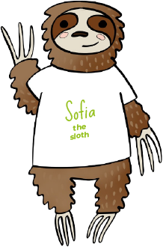
Caring for God’s gifts
Stewardship
Sofia the sloth’s story
Sofia often sleeps in her favourite tree within a National Park forest.

One day a big machine woke her up and started chopping down the trees. She joins some of the others who call the forest home, to stop the illegal logging.

She reminds the operators that these trees need to be cared for like the rest of God’s creation.

From Sofia’s story we find out that we need to be caring for the many gifts that God has given to us. These include our environment, our own talents and other resources.

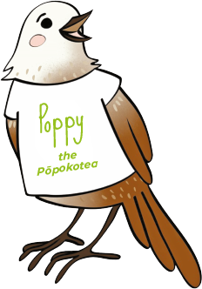
Putting people most
in need first
Preferential option for the poor
Poppy the pōpokotea’s story

When Poppy hatched she was all alone and never knew her parents. She remembers having to rely on kind birds caring for he and bringing her worms to eat.

As one of the youngest and most vulnerable, she understands what it was like to have nothing and the need to rely on others.

She is much older now and has started a “Worms-4-U” service for birds in need everywhere.

Poppy’s story tells us that we should think first about the needs of people who need help the most.

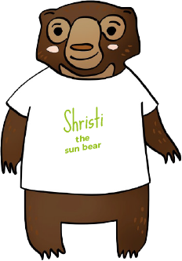
Showing we care
Solidarity
Shristi the sun bear’s story
Shristi is one of the biggest animals in her neck of the woods. However, she also has the kindest heart.

A fire destroyed part of her forest and many animals lost their homes and were injured and couldn’t live like they used to. Shrisiti was the first to visit them and shared time with them, learning what it was like to lose your home.

After becoming friends, she made sure that they found new homes and were happy with their new lives. Her actions inspired lots of other animals to follow.

We learn from Shristi’s story that we must recognise others as our brothers and sisters and actively work for their good.

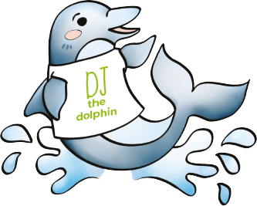
Sharing fairly
Distributive Justice
DJ the dolphin’s story

DJ is part of a large family of dolphins (a pod) His family take turns to catch their food (usually fish).

Some of his older brothers and sisters don’t share all that they catch on purpose. DJ, being one of the youngest, is often given a small portion while some of the others take a few each.

DJ is not afraid to tell his family that this is not fair.

Like DJ we should make sure that everyone gets their fair share.

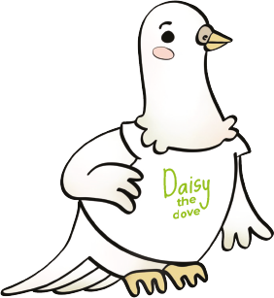
Being peacemakers
Promoting Peace
Daisy the dove’s story

Daisy lives in a tough neighbourhood where some of the animals try to use their size to bully others.

She is not afraid to be a peacemaker and remind others to be caring and kind. Every day she sings a beautiful tune to keep everyone calm and speaks kind words to all around her to build up their self-esteem.

Some days are harder than others and more challenging. However, she knows it is important to keep working for a world full of peace.

Daisy’s story reminds us that it is important to keep working to build a more peaceful world.

